# Farty Buttz

Game Design Document

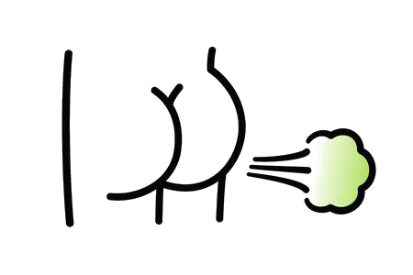

|  |  |  |  |
| --- | --- | --- | --- |
| Revision Number | Edited By | Date of Change | Description |
| 1.0 | Thomas Harper | 4/10/2020 | Initial Creation |

Table of Contents

Revisions……………………………………………………………….2

Summary………………………………………………………………2

Targets…………………………………………………………………2

Gameplay…………………………………………………………….2

Art………………………………………………………………………2

Audio.........……………………………………………………………2

Revisions………………………………………………………………2

Revisions………………………………………………………………2

Revisions………………………………………………………………2

Revisions………………………………………………………………2

Revisions………………………………………………………………2

Revisions………………………………………………………………2

Revisions………………………………………………………………2

Revisions………………………………………………………………2

Revisions………………………………………………………………2

Revisions………………………………………………………………2

Revisions………………………………………………………………2

Summary

Elevator Pitch

Flappy Bird meets flying farting butts to bring one of the funniest and unique mobile experiences you *have* to try for yourself.

Minimum Viable Product (MVP)

* Flappy Bird Mode
  + One Butt with the ability to fart through “pipes”
  + Lose by hitting an obstacle
  + Show a score and save the high score locally

Features

* Customize your playable Butts
  + Each with their own unique farting particles and sounds (Please reference Art Document for more information)
* Selectable Game Modes
  + Zen Mode - Original Flappy Bird
  + Arcade Mode - Dodge obstacles and get high scores
  + TBD – To Be Decided
* Social Modes – Invite Friends, High scores, etc. (Also TBD)

Targets

Platform(s)

Mobile and Tablets – Android and iOS devices

Target Audience

Anyone 7+ with a mobile device or tablet

Gameplay

Design Pillars

//To be updated

Core Loop

Fly between pipes by tapping the screen to initiate jumping between pipes to earn points.

Mechanics

Farting, Changing Buttz and Backgrounds

Game Flow

//To be updated

Game Modes

Each game mode will have similar controls with different objectives

* Arcade Mode
  + - Try to dodge obstacles and get a score based on how long you go, collecting power ups along the way. You can use “gems” to keep going and build a score for more unlockables.
* Zen mode
  + - Original Flappy Bird Mode where you flap through pipes and get a high score based on how many pipes you pass through. You can use “gems” to continue going and get more unlockables.
* Challenge Mode
  + - Each Butt you unlock will have a unique set of challenges that will include landing on a platform, timing jumps between obstacles, seeing if you can reach a certain altitude in a small amount of time, and possibly more.

Game Customization

As you collect some in-game currency, the player will be able to spend that currency buying different Buttz, pipes, etc.

Buttz

There will be 20 different Buttz to choose from.

//Link to all of the different Buttz

Pipes

There will be 10 different Pipe Styles with different backgrounds the player will be able to choose from.

//Link to all of the different Pipes

Art

Art Board:

<https://trello.com/c/C9NQ2DOn/2-art>

*Link to Art Design Document*

Audio

Audio Board:

<https://trello.com/c/4os0qz0y/3-audio>

*Link to Audio Design Document*